**Project Design Phase-II**

**Data Flow Diagram & User Stories**

|  |  |
| --- | --- |
| Date | 20 October 2022 |
| Team ID | PNT2022TMID31649 |
| Project Name | A Novel Method for Handwritten Digit Recognition System |
| Maximum Marks | 4 Marks |

**Data Flow Diagram:**

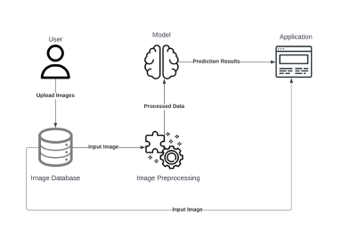 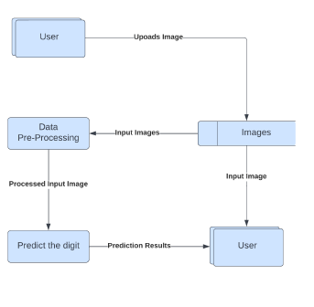

**User Stories**

Use the below template to list all the user stories for the product.

| **User Type** | **Functional Requirement (Epic)** | **User Story Number** | **User Story / Task** | **Acceptance criteria** | **Priority** | **Release** |
| --- | --- | --- | --- | --- | --- | --- |
| Customer (Mobile user) | Accessing the Application | USN-1 | As a user, I should be able to access the application from any device a any time | I can access the application using the browser on any device | High | Sprint-4 |
|  | Uploading Image | USN-2 | As a user, I should be able to upload images to predict the digits | I can upload images | High | Sprint-3 |
|  | Viewing the Results | USN-3 | As a user, I should be able to view the results | Digits are predicted and displayed | High | Sprint-3 |
|  |  | USN-4 | As a user, I should be able to see other close predictions | The accuracy of other values must be displayed | Medium | Sprint-4 |
|  | Usage Instruction | USN-5 | As a user, I should have a usage instruction to know how to use the application | The usage instruction is displayed on the home page | Medium | Sprint-4 |